Question type | Question | Remarks
Quality | What is Software Quality?
Testing type | What are black box, white box and grey box testing? With example.  What are other names of black box and white box testing?
Bug question | What is Pareto Analysis?  Difference between bug and defect
Agile | What are the different roles in Scrum process?  What is Agile manifesto?
Difficult testing type | What is soak Testing?  Mention what is the purpose behind doing end-to-end testing?  What is end to end testing?  What is API Testing?
Database | What are the subsets of SQL?What is data definition language?
Database | What is data manipulation language?What are the type of operators available in SQL?
Numerical | In a system designed to work out the tax to be paid:  An employee has £4000 of salary tax free.  The next £1500 is taxed at 10%.  The next £28000 after that is taxed at 22%.  Any further amount is taxed at 40%.  To the nearest whole pound, which of these groups of numbers fall into three DIFFERENT equivalence classes?  a) £4000; £5000; £5500  b) £32001; £34000; £36500  c) £28000; £28001; £32001  d) £4000; £4200; £5600
Puzzle | There where six apples in a basket and six girls in the room. Each girl took one apple, yet one apple remained in the basket how ?
Version | Latest version of Mozilla Firefox
Test case problem | Write test cases for Program Management Figure 3?  Write test cases of ceiling fan?
Bug problem | What Bugs have you find in the Application you tested?  What is the biggest bug in this application?
Tools | Name some Bug Tracking tools

Question type | Question | Remarks
Quality | What is software quality Assurance?
Testing type | What are levels of testing? Explain component, integration, system and UAT tetsing with example.
Bug question | What different types of things are included in a Bug Report?  What is latent and golden Bug?
Agile | What is Scrumban methodology for Agile environment?  What is tracer bullet?
Difficult testing type | What is gorrila testing?  What is independent testing?
Database | What is the difference between DELETE and TRUNCATE statement in SQL?  What is a primary key? What is a Unique Key ?
Database | What is ACID property in database?
Numerical | An input field takes the year of birth between 1900 and 2004.  The boundary values for testing this field are:  a. 0,1900,2004,2005  b. 1900, 2004  c. 1899,1900,2004,2005  d. 1899, 1900, 1901,2003,2004,2005
Puzzle | Two men were playing tennis. They played five sets and each man won three sets. How did they do this ?
Version | Latest version of Bugzilla (4.4.12) 4.4.12
Test case problem | Write test cases for Flow chart 3?  Write test cases of Pen?
Bug problem | What Bugs have you find in the Application you tested?  What is the biggest bug in this application?
Tools | Name some task management tools used in Agile to track the status of different sprint.

Question type | Question | Remarks
Quality | What is Qulaity aduit and Inspection?
Testing type | Give example of functional and Non-functional testing.  What is static and dynamic testing.
Bug question | What are the different status in Bug Life cylce?  What is reproducing a bug?
Difficult testing type | What is Agile testing?  What is Database testing?
Agile | Why Scrum methodology is more popular for Agile environment?  What is a test stub?
Database | Define SQL Delete Statement ?
Database | Right Join
Numerical | A program validates a numeric field as follows: values less than 10 are rejected, values between 10 and 21 are accepted, values greater than or equal to 22 are rejected. Which of the following covers the MOST boundary values?  a. 9,10,11,22  b. 9,10,21,22  c. 10,11,21,22  d. 10,11,20,21
Puzzle | A man has 53 socks in his drawer: 21 identical blue, 15 identical black and 17 identical red. The lights are fused and he is completely in the dark. How many socks must he take out to make 100 per cent certain he has a pair of black socks?
Version | Latest version of Google Chrome
Test case problem | Write the test cases for Instagram?  Write test cases for Hardware of Mobile device?
Bug problem | What Bugs have you find in the Application you tested?
Tools | How to perform configuration testing? Can we use some tools for this

Question type | Question | Remarks
Quality | What is quality control?
Testing type | What is adhoc testing and random testing? Give example  What is compatibility and configuration testing?
Bug question | What are different of type of Bugs?
Agile | What are the advantages and disadvantages of Agile Environment?  In Agile mention what is the difference between the Incremental and Iterative development?
Difficult testing type | Explain exploratory testing.
Database | Outer Join
Database | Left Join
Numerical | In a system designed to work out the tax to be paid:  An employee has £4000 of salary tax free.  The next £1500 is taxed at 10%.  The next £28000 after that is taxed at 22%.  Any further amount is taxed at 40%.  To the nearest whole pound, which of these is a valid Boundary Value Analysis test case?  a) £28000  b) £33501  c) £32001  d) £1500
Puzzle | How many cases do you need if you have to pack 112 pairs of shoes into cases that each hold 28 shoes?
Version | Latest version of Opera
Test case problem | Write test cases for Program Management?  Write test cases of Motor cycle?
Bug problem | What Bugs have you find in the Application you tested?
Tools | How to perform system testing? What tools are used for the same?

Question type | Question | Remarks
Quality | What is the difference between Quality control and Quality assurance?
Testing type | What is concurrency testing?Example  What is smoke testing?Example  What is load testing?Example
Bug question | What causes bugs in the software?
Agile | What isBrun up chart?  Explain what is Spike
Difficult testing type | How do drivers and stubs relate to manual testing?  What are the advantages of automation testing?
Database | Full Join
Database | Self Join
Numerical | This pseudo code is given:  Integer a;  If (a > 1 AND a < 50)  Then …  End if  Which of the following collections of test input values is the correct result of a boundary value analysis?  a) 0, 1, 2, 50, 51  b) 1, 2, 49, 50  c) -1, 0, 1, 2, 49, 50, 51  d) -32767, -1, 0, 1, 49, 50, 51, +32768
Puzzle | In a party of 35 people there are twice as many women as children and twice as many children as men. How many of each are there?
Version | Latest version of IE
Test case problem | What are the test cases for the flowchart 2  write test cases for Wrist watch?
Bug problem | What Bugs have you find in the Application you tested?  What is the biggest bug in this application?
Tools | How to perform Component testing?  What is test suite and test specification?

Question type | Question | Remarks
Quality | What is Cost of Quality?
Testing type | What is performance testing?Example  What is recovery testing? Example.  What is security testing? Example.
Bug question | How would you say that a bug is 100 % fixed ???
Agile | What is Sprint backlog?  Mention in detail what are the role’s of Scrum Master?
Difficult testing type | What are the primary techniques to design test cases for black box testing?
Database | Cross Join
Database | What is a view? What are the advantages and disadvantages of views in a database?
Numerical | Order numbers on a stock control system can range between 10000 and 99999 inclusive. Which of the following inputs might be a result of designing tests for only valid equivalence classes and valid boundaries:  A. 1000, 5000, 99999  B. 9999, 50000, 100000  C. 10000, 50000, 99999  D. 10000, 99999  E. 9999, 10000, 50000, 99999, 10000
Puzzle | A factory was cutting rolls of cloth into 1 metre lengths, from a 200 metre roll. How long would it take for the machine to cut the roll if each cut took 4 secs?
Version | Latest version of MAC
Test case problem | What are the test cases for the flowchart 2  Write test cases for Microwave oven?
Bug problem | What Bugs have you find in the Application you tested?
Tools | Name some tools used in Agile testing.

Question type | Question | Remarks
Quality | How Quality assurance affect cost of maintenance?
Testing type | What is structural testing? Example.  What is usability testing? Example.  What is volume testing? Example.
Bug question | If a bug is not reproduceable then what testing team will do?
Agile | What is product backlog?  Explain what is Application Binary Interface?
Difficult testing type | What is exploratory testing.  What is mutation testing?
Database | What is a trigger?
Database | Explain the difference between DELETE , TRUNCATE and DROP commands?
Numerical | In a flight reservation system, the number of available seats in each plane model is an input. A plane may have any positive number of available seats, up to the given capacity of the plane. Using Boundary Value analysis, a list of available – seat values were generated. Which of the following lists is correct?  a. 1, 2, capacity -1, capacity, capacity plus 1  b. 0, 1, capacity, capacity plus 1  c. 0, 1, 2, capacity plus 1, a very large number  d. 0, 1, 10, 100, capacity, capacity plus one
Puzzle | A farmer told his labourer to pick 896,809 apples and pack them into as few boxes as possible, each having the same number of apples. How many boxes did he use?
Version | Latest version of Safari
Test case problem | If the customer requirements are changing continuously as a tester how you are going to manage the situation?Suppose you have prepared test cases but still some more time is required to receive the build in between time what you can do?How you know the bug you sent is fixed or not?  Write test cases for flowchart 3?
Bug problem | What Bugs have you find in the Application you tested?
Tools | What is JIRA?

Question type | Question | Remarks
Quality | What are the best practices for software quality assurance?
Testing type | What is Stress testing? Example.  What is localization testing? Example.  What is soak testing? Example
Bug question | What is vertical and horizental Traceability Matrix?
Agile | What is time boxing in agile?  How do you deal when requirements change frequently?
Difficult testing type | What all things you should consider before selecting automation tools for the AUT?
Database | What is Union, minus and Interact commands?
Database | What is schema?
Numerical | Assume postal rates for ‘light letters’ are: $0.25 up to 10 grams $0.35 up to 50 grams $0.45 up to 75 grams $0.55 up to 100 grams Which test inputs (in grams) would be selected using boundary value analysis?  a) 0, 9, 19, 49, 50, 74, 75, 99, 100  b) 10, 50, 75, 100, 250, 1000  c) 0, 1, 10, 11, 50, 51, 75, 76, 100, 101  d) 25, 26, 35, 36, 45, 46, 55, 56
Puzzle | A photograph measuring 8.5 by 7.5 cm is to be enlarged. If the enlargement of the longer side is 13.6 cm, what is the length of the smaller side?
Version | Latest version of Andriod
Test case problem | What are the test cases for the flowchart 2  What are the test cases for Car?
Bug problem | What Bugs have you find in the Application you tested?
Tools | What is KANBAN?

Question type | Question | Remarks
Quality | How Quality assurance affect cost of development?
Testing type | What is gorilla testing?  What is difference between desktop application testing and web application testing?  What types of testing is done for desktop application software?
Bug question | What is bug free software release?
Agile | When not to use Agile?  Mention what is the difference between Scrum and Agile?
Difficult testing type | What is difference between Test matrix and Traceability matrix?  Define fifth phase of STLC?
Database | What is the difference between Cluster and Non cluster Index?
Database | What is the difference between having and where clause?
Numerical | In an Examination a candidate has to score minimum of 24 marks in order to clear the exam. The maximum that he can score is 40 marks. Identify the Valid Equivalence values if the student clears the exam.  a) 22,23,26  b) 21,39,40  c) 29,30,31  d) 0,15,22  Also explain the number of classes and ranges of these classes.
Puzzle | A bag contains 64 balls of eight different colours. There are eight of each colour (including red). What is the least number you would have to pick, without looking, to be sure of selecting 3 red balls?
Version | Latest version of Dolphin browser
Test case problem | What are the test cases for the flowchart 1  What are the test cases for Spectacles?
Bug problem | What Bugs have you find in the Application you tested?
Tools | What is Burndown chart?

Question type | Question | Remarks
Quality | What are the international standards for Quality assurance?
Testing type | What is difference between Retesting and Regression testing?  What is difference between Automation and Manual testing?
Bug question | Mention what is the difference between a "defect" and a "failure" in software testing?
Agile | What is Zero sprint in Agile?  What is Test Driven Development (TDD)?
Difficult testing type | What is Fuzz testing and when it is used?  Define fourth phase of STLC?
Database | How to print duplicate rows in a table?
Database | What is the difference between Trigger and Stored Procedure?
Numerical | One of the fields on a form contains a text box which accepts numeric values in the range of 18 to 25. Identify the invalid Equivalence class.  a) 17  b) 19  c) 24  d) 21  Also explain the number of classes and ranges of these classes.
Puzzle | How many times a day do the minute and hour hands of a clock overlap?
Version | Latest version of Mozilla Firefox
Test case problem | Write test cases for calculator.  Write test cases for Program Management?
Bug problem | What Bugs have you find in the Application you tested?
Tools | Can we use TCMS to report bugs at Bugzilla

Question type | Question | Remarks
Quality | How as a tester you can provide Qulaity to software?
Testing type | Explain Compatibility testing with an example.  What is the difference between Waterfall and iterative waterfall methodlogy.  What is RAD model? What are its advantages and disadvantages.
Bug question | Explain Bug life cylce in detail.
Agile | Explain Pair Programming  What is difference between Epic, User stories & Tasks?  What are the different methodology used for Agile Testing?
Difficult testing type | What is static testing? Name testing types that are performed in static testing.  Define third phase of STLC?
Cloud | Mention platforms which are used for large scale cloud computing? Explain different models for deployment in cloud computing?
Cloud | In cloud computing what are the different layers?  List down the basic characteristics of cloud computing? Mention what is the difference between elasticity and scalability in cloud computing?
Numerical | When priority and Severity is opposite then which one required to solved first?  Bug Number 1=Severity 1 & priority 3,  Bug Number 2=severity 3 & priority 1,
Puzzle | You are given two candles of equal size, which can burn 1 hour each. You have to measure 90 minutes with these candles. (There is no scale or clock). Also u r given a lighter.
Version | Latest version of Google Chrome
Test case problem | What are the test cases for the flowchart 1  write test cases for VLC player?
Bug problem | What Bugs have you find in the Application you tested?
Tools | Name some tools that can help Manaul tester to perform security testing

Question type | Question | Remarks
Quality | Could reviews or inspections be considered part of testing? If yes then why or if no then why?  Ans:Yes, because both help detect faults and improve quality.
Testing type | What is Monkey, Random testing with example  What is V-model? What are its advanatges and disadvanatges.  What is the difference between Authentication and authorization.
Bug question | How to select the correct bug type?  What are Test Metrices?
Agile | What is Agile Testing with example  What is Velocity in Agile?
Difficult testing type | Mention what is the difference between Pilot and Beta testing?  Define second phase of STLC?
Cloud | Explain hybrid and community cloud?
Cloud | What is the difference between cloud computing and mobile computing?
Numerical | A wholesaler sells printer cartridges. The minimum order quantity is 5. There is a 20% discount for orders of 100 or more printer cartridges. You have been asked to prepare test cases using various values for the number of printer cartridges ordered. Which of the following groups contain three test inputs that would be generated using Boundary Value Analysis?  4, 5, 99
Puzzle | You have two beakers – one of 4 liters and other of 5 liters. You are expected to pour exactly 7 liters in a bucket. How will you complete the task?
Version | Latest version of Bugzilla
Test case problem | What are the test cases for Printer device?  What are the test cases for Maggi?
Bug problem | What Bugs have you find in the Application you tested?
Tools | Name some tools that can help Manaul tester to perform performance testing
Question type | Question | Remarks
Quality | How quality control, Qulaity assurance and testing are interrelated?
Testing type | What is alpha , beta and gamma testing? Give example.  - What is verification and validation? Give example  What is review, Audit, Walkthrough and Inspection?  How to perform experience based testing?
Bug question | What is severity and priority of bug? Give some example.
Agile | - Explain the difference between traditional Waterfall model and Agile testing?  - What is re-factoring?  - What meetings takes place in Scrum Process?
Difficult testing type | Gorrila testing. Give example.  Define first phase of STLC?
Cloud | What is "EUCALYPTUS" in cloud computing? Why is it used?
Cloud | Give some example of large cloud provider and databases?  What do you mean by CaaS?What do you mean by VPN? What does it contain?
Numerical | An input field takes the year of birth between 1900 and 2004 what are the boundary values for testing this field?  1899,1900,2004,2005
Puzzle | Numbers of Zero at the end of 100 !?
Version | Latest version of JIRA
Test case problem | Write test case for Rotating chair?  What are the test cases for program managment?
Bug problem | What Bugs have you find in the Application you tested?
Tools | Name some tools that can help Manaul tester to perform load testing

Flowchart 1

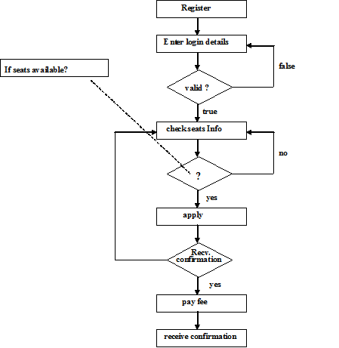

Flowchart 2

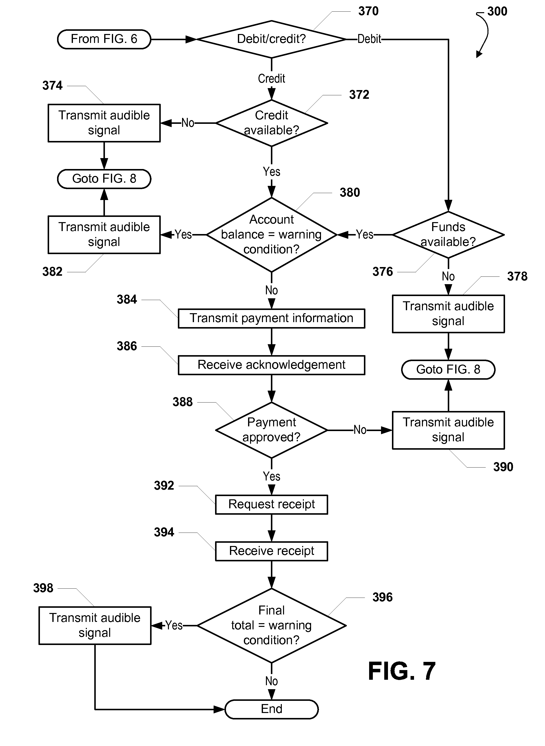

Program Management
This module will cover program related operations add, edit, delete and view of program.

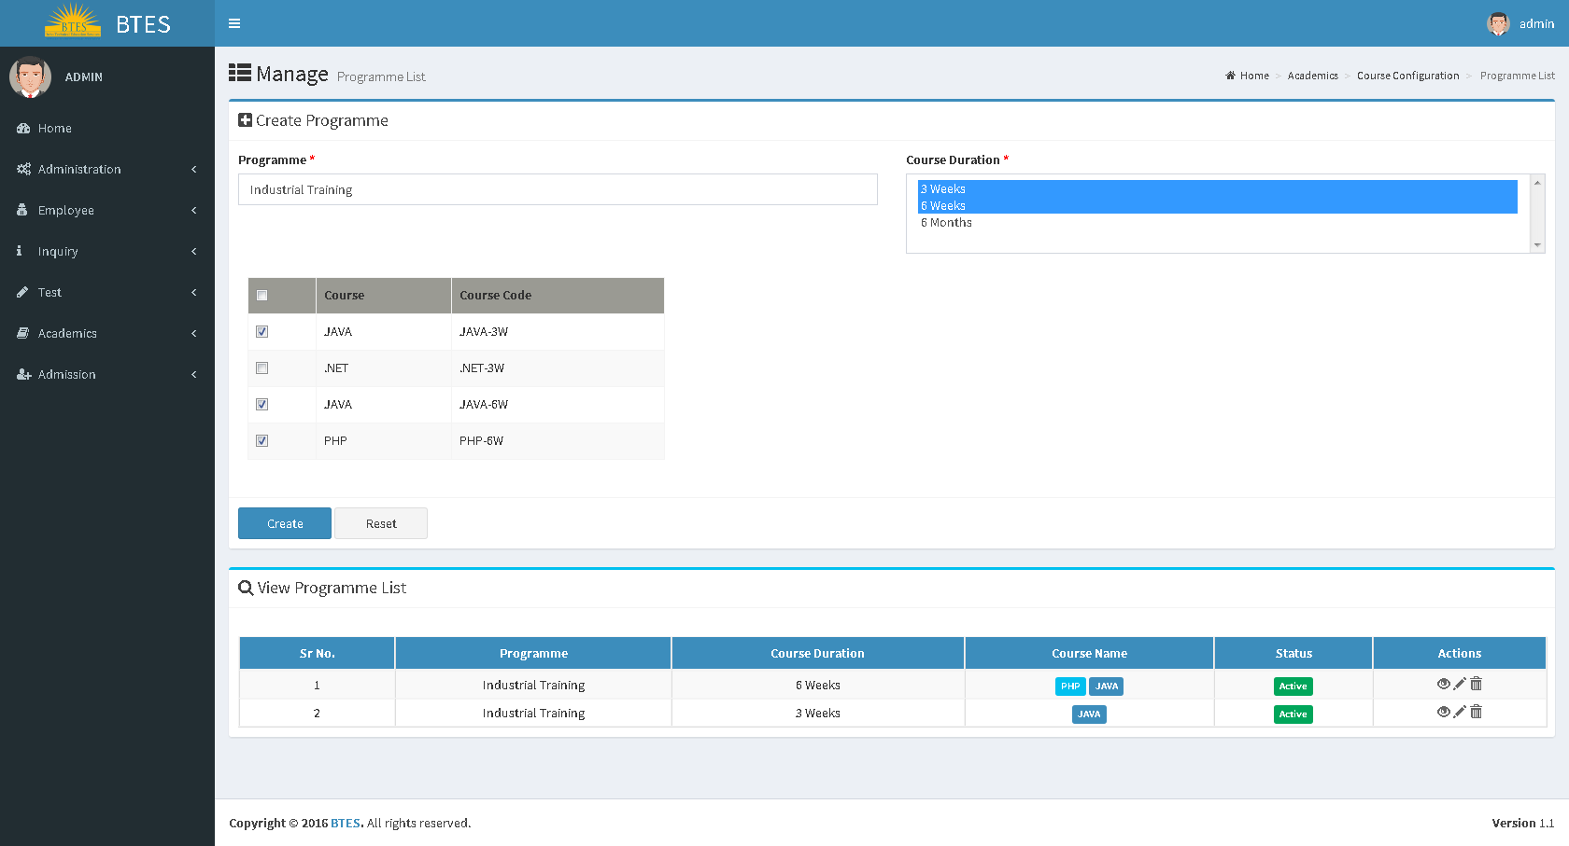
Components
Form to create program
The form will have 2 fields and list as
    - Program: There will be an input box to set name to new program. This field will be mandatory.
    - Program Duration: There will be a drop down to choose program duration. There will be multiple select features. This field will be mandatory.
    - List of courses: This list will be fetched as per the selected program duration. This list will have following fields:
              - Checkbox
              - Course Name
              - Course Code
List of Program: This list will have following fields:
    - Sr No
    - Program Name
    - Program Duration
    - Course Name
    - Status (Active or Inactive)
    - Actions( View, Edit and Delete)
Assumptions
Program will be the combination of program name + program duration + course list

Flow chart 3

Status:In Progress
Status:Screening Test-1
First Chance
Clear?
Second Chance
Clear?
Registration Fees
Paid
Status:Admission
Third chance clear?
Fee Paid for Paid chance?
Status: Disqualified
NO
Yes
Yes
Yes
Yes
Yes
No
No
No
Yes
Student Opts for Placement

Status:Screening Test-2
Notify the Counsellor that fee is pending
No
Status:Screening Test-3
Student Option
For Placement

